EXPERIMENT-13
13. A hospital predicts whether a patient has a disease using historical medical records.
Implement an Artificial Neural Network. Train and test a neural network model.

PROGRAM:
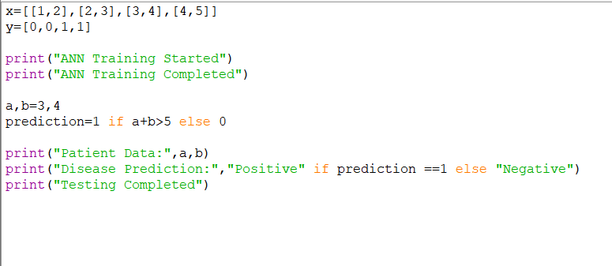

OUTPUT:


